Final Review  
1. Toh

2. read/write disk

3. previous finals

Write a function that prints out the n values of the search tree in descending order:

Print_desc(n)

{

If (n==null) return;

Print_desc(n.right);

Print_desc(n.value);

Print_desc(n.left);

}

Worst case time: O(n)

Worst space: O(n)  
**Because you would have to print everything in this case**

4. previous finals

Show a tree where you can remove a node without needing to rebalance the avl tree  
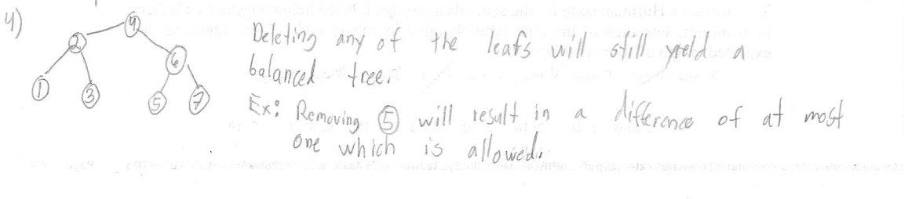

5. Euclid alg/ prev finals  
<https://www.calculatorsoup.com/calculators/math/modulo-calculator.php>  
EXCEL  
<https://replit.com/@SaimAli6/leiss#main.py>

6. prev test2s/finals

**(A)**[**https://www.cs.usfca.edu/~galles/visualization/BST.html**](https://www.cs.usfca.edu/~galles/visualization/BST.html)

a)

b)

**(B)**[**https://www.cs.usfca.edu/~galles/visualization/AVLtree.html**](https://www.cs.usfca.edu/~galles/visualization/AVLtree.html)

a)

b)

7. Huffman code  
<https://huffman.ooz.ie/>

Huffman Encoding Guide:

1. Set up characters with the lowest frequency to highest.

2. Select 2 lowest frequencies, connect them, then add them together.

3. Label 0 for smaller number, 1 for big number (If the 2 values are the same, label 0 for left value, 1 for right).

4. Go back to step 2 until only 1 value remains.

5. Starting from the end of the tree, trace it to the letter to determine its code.

6. Once all characters' codes are determined, count the amount of digits for each code to get its length.

7. Once all lengths are determined, compute for the final result.

8. idk

9. idk  
  
RSA QUESTION : Also, answer for RSA question is O(2logn.m^(log3)). Dont ask me how, TA wrote that as answer in my midterm paper.